
PICH Produce Prescription Intake Questionnaire 2020

You are being invited to participate in a research study titled “PICH Produce Prescription Program” being conducted by Drs. Stephanie Jilcott Pitts and Ann Rafferty, faculty members at East Carolina University in the Department of Public Health. You are being asked to complete this survey because you are enrolled in a nutrition education program that partners with the PICH Produce Prescription Program, a program to promote the use of farmers’ markets that sell locally grown, fresh fruits and vegetables in your community.
Due to COVID-19, this program will possibly be implemented online in some counties depending on whether existing nutrition education programs choose to conduct their educational sessions online.

Please complete this survey about eating fruits and vegetables, and shopping at farmers’ markets. The survey will take about 10-15 minutes to complete. You may skip any questions that you do not want to answer or stop at any time. There is no penalty for not taking part in this research. Your participation is voluntary.
After completing the survey, you will receive vouchers for farmers’ markets or small stores. When you use the vouchers, please answer the questions on the back of the voucher, which will take 5 minutes or less. If we do not receive a follow-up survey from you on the voucher, we may text you the link to the survey or call you to ask the survey questions. The information you give us will help us make the produce prescription program even better in the future. Your responses will be kept confidential and no data will be released or used with your identification attached.
Please call Dr. Stephanie Jilcott Pitts at 252-744-5572 for any research related questions or the University & Medical Center Institutional Review Board (UMCIRB) at 252-744-2914 for questions about your rights as a research participant.

These first 2 questions ask about the amount of fruits and vegetables you usually eat each day. Please think about what you ate in the past 7 days. Choose one answer for each question by marking the box with an X.
From
- Townsend MS, Sylva K, Martin A, Metz D, Wooten-Swanson P. Improving readability of an evaluation tool for low-income clients using visual information processing theories. J Nutr Educ Behav. 2008; 40(3):181-186.
- Townsend MS, Kaiser LL, Allen LH, Joy AB, Murphy SP. Selecting items for a food behavior checklist for a limited-resource audience. J Nutr Educ Behav. 2003;35(2):69-82.
- Trapl ES, Joshi K, Taggart M, Patrick A, Meschkat E, Freedman DA. Mixed methods evaluation of a produce prescription program for pregnant women. J Hunger Environ Nutr. 2017;12(4):529-543.

- Fruit: How much fruit did you eat each day during the past 7 days?
None  □ | ½ Cup  □ | 1 Cup  □ | 1 ½ Cups  □ | 2 Cups  □ | 2 ½ Cups  □ | 3 cups or more  □

- Vegetables: How much vegetables did you eat each day during the past 7 days?
None  □ | ½ Cup  □ | 1 Cup  □ | 1 ½ Cups  □ | 2 Cups  □ | 2 ½ Cups  □ | 3 cups or more  □

- What makes it hard for you to eat fresh fruits and vegetables? (check all that apply)
- They are not available in my neighborhood
- I do not have enough money to buy them
- I do not have enough space to store them
- I do not have enough time to cook/prepare them
- They spoil too quickly
- I have health-related dietary restrictions or dental problems
- Transportation is an issue for me
- Other, please list ________________________________________________
OR
- It is NOT HARD for me to eat fresh fruits and vegetables
These next questions ask about your food shopping patterns.

- Thinking about the past month, what types of stores and markets have you or your family gone to for food? Do not include restaurants. (Check all that apply)
- Supermarket, Grocery Store, Supercenter, or Warehouse
- Convenience, Dollar Variety, or Corner Store
- Farmers’ Market
- Food Pantry or Shelter
- Other, please list _____________________________________________

5. Have you ever shopped at a farmers’ market?
- Yes
- No
6. How much do you agree or disagree with the following statements about farmers’ markets? Even if you haven’t been to a farmers’ market, please make your best guess. (Mark your response with an X in the box)

 | 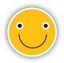  Agree | 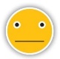  Neither agree nor disagree | 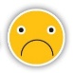  Disagree
I am interested in shopping at farmers’ markets. | □ | □ | □
It is easy for me to get to farmers’ markets. | □ | □ | □
I feel welcome at farmers’ markets. | □ | □ | □
The staff and vendors at farmers’ markets are easy to talk to. | □ | □ | □
Farmers’ markets sell good quality, fresh food. | □ | □ | □
Farmers’ markets always have the fruits and vegetables I want. | □ | □ | □
The prices of fruits and vegetables at farmers’ markets are low compared to grocery stores. | □ | □ | □
Farmers’ markets are a good place to meet new people. | □ | □ | □

For the next two questions please read the statement and tell us whether this statement is often, sometimes, or never true for you. Questions 7 and 8 from: Hager ER, Quigg AM, Black MM, et al. Development and validity of a 2-item screen to identify families at risk for food insecurity. Pediatrics. 2010;126(1):e26-e32.

- Within the past 12 months we worried whether our food would run out before we got money to buy more.
- Often true
- Sometimes true
- Never true
- Don’t know/ Refused to answer

- Within the past 12 months the food we bought just didn’t last and we didn’t have money to get more.
- Often true
- Sometimes true
- Never true
- Don’t know/ Refused to answer

- What type of education or information did you receive, if any, before being admitted into this produce prescription program?
-healthy lifestyles or habits-nutrition-chronic conditions-canning, preserving foods, or gardening-other information-I did not receive any education or information before receiving these vouchers

- Do you feel more confident to improve your current health habits after talking with your provider or educator about this program?
-yes-no-I did not talk with anyone before receiving these vouchers

- If you were to receive vouchers once every month, what amount of vouchers would you hope to receive?
$ _______ per month
These last questions ask a little bit about you and programs you may participate in.

- Do you currently use SNAP/EBT?
- Yes
- No

- Do you currently use WIC?
- Yes
- No

- How old are you? _______ years

- What is your sex?
- Female
- Male

- How many people, including you, live in your household? _______ people

- How do you describe your race/ethnicity? (Check all that apply)
- African American / Black  - Native American / American Indian  - Latino / Hispanic or Spanish Origin | - Caucasian / White  - Asian / Asian American  - Other race or ethnicity

- What is the highest level of education you have completed? (Check one)
- Less than high school
- High school diploma or GED
- Some college
- College degree or more

We would like to follow-up with Program participants on their experiences with the program.

Would it be okay to contact you after you finish the program?
- Yes
- No
If YES, please provide your preferred contact information below:
Phone number 1: ______________________________
Phone number 2 (optional):______________________
Email address: ________________________________
Full name: ___________________________________
Mailing address: ________________________________
Street: ________________________________
City, State, Zip: ________________________________

2021 voucher:
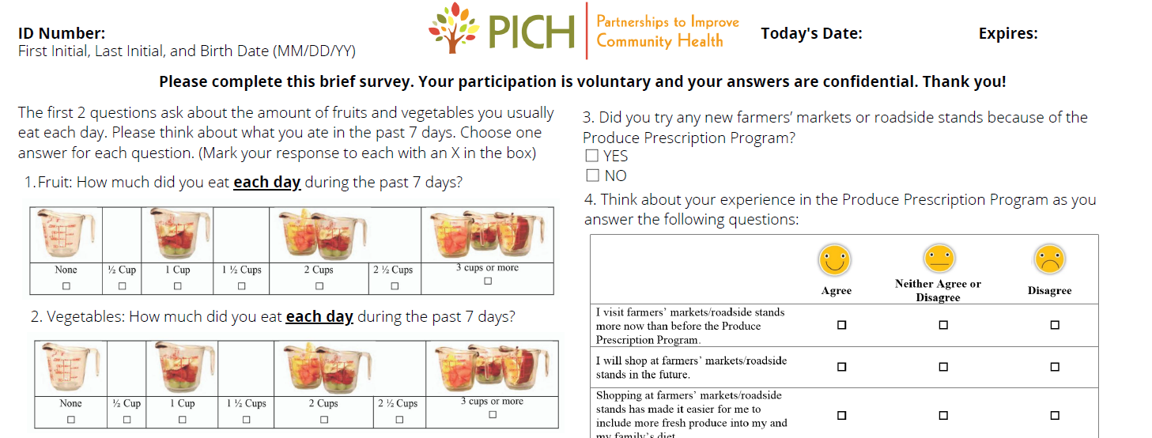

2022 voucher:

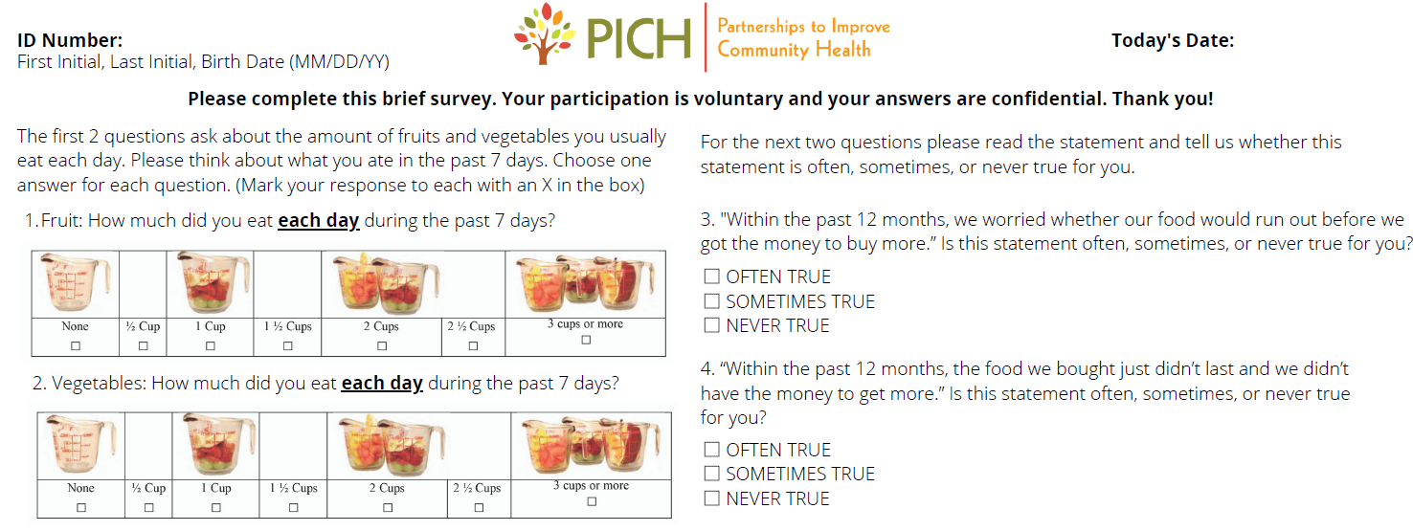

 | Informed Consent to Participate in Research  Information to consider before taking part in research that has no more than minimal risk.
The interviewer will read all elements of the consent sheet below and will ask the participant if they have any questions. The interviewer will record the date and time the phone call occurred, interviewer name, and any questions asked and answered, as well as document that the participant agreed to participate – all on the consent documentation form.

The title of this research study is “Partnerships to Improve Community Health (PICH) Produce Prescription Evaluation. The Sponsor/Funding Source is Kate B. Reynolds Charitable Trust. The Principal Investigator is Dr. Stephanie Jilcott Pitts, Department of Public Health,115 Heart Drive, Greenville NC 27834; 252-744-5572.

Researchers at East Carolina University (ECU) study issues related to society, health problems, environmental problems, behavior problems and the human condition. To do this, we need the help of volunteers who are willing to take part in research.

The purpose of this research is to evaluate the PICH Produce Prescription Program. You are being invited to take part in this research because you are a person who participated in the PICH Produce Prescription Program, over the age of 18, and an English speaker. The decision to take part in this research is yours to make. By doing this research, we hope to assess the dietary impact of produce prescription vouchers on recipients and learn how to improve this program from the participant perspective.

If you volunteer to take part in this research, you will be one of about 30 – 45 people to do so.

You should not volunteer for this study if you are under 18 years of age, not an English speaker, and not a person who participated in the PICH Produce Prescription Program.
You can choose not to participate.
The research will be conducted over the phone. The total amount of time you will be asked to volunteer for this study will be 30-45 minutes.
You will be asked to do the following: First, you will be asked to listen to me explain this study. You may ask questions at any time. After you agree to participate, we will proceed with the interview. We will ask you several questions about the produce prescription program. We will audio-record this interview. The audio recording will be downloaded to a password protected computer and transcribed verbatim. The electronic transcripts will be kept for 3 years. Only study staff will be given access to these transcripts. The audio recordings will be deleted from the recorder after transcription.
We don’t know of any risks (the chance of harm) associated with this research. Any risks that may occur with this research are no more than what you would experience in everyday life. We don't know if you will benefit from taking part in this study. There may not be any personal benefit to you, but the information gained by doing this research may help others in the future.
We will not be able to pay you for the time you volunteer while being in this study.
It will not cost you any money to be part of the research.
ECU and the people and organizations listed below may know that you took part in this research and may see information about you that is normally kept private. With your permission, these people may use your private information to do this research:
- The sponsors of this study.
- Any agency of the federal, state, or local government that regulates human research. This includes the Department of Health and Human Services (DHHS), the North Carolina Department of Health, and the Office for Human Research Protections.
- The University & Medical Center Institutional Review Board (UMCIRB) and its staff have responsibility for overseeing your welfare during this research and may need to see research records that identify you.

We will keep all information (audio recordings and verbatim transcripts) on password protected computers and in locked filling cabinets in a locked research office. The transcripts of the recordings could be used for teaching purposes or training purposes. If used for these purposes, the transcripts will be stripped of identifiers and used in future research without anyone knowing it is information from you. We will keep audio recordings for no more and transcripts for no more than 3 years.

You can stop at any time after it has already started. There will be no consequences if you stop and you will not be criticized. You will not lose any benefits that you normally receive.
The people conducting this study will be able to answer any questions concerning this research, now or in the future. You may contact the Dr. Stephanie Jilcott Pitts at 252-744-5572 (M-F, between 9 am to 5 pm). If you have questions about your rights as someone taking part in research, you may call the University & Medical Center Institutional Review Board (UMCIRB) at phone number 252-744-2914 (days, 8:00 am-5:00 pm). If you would like to report a complaint or concern about this research study, you may call the Director for Human Research Protections, at 252-744-2914.

PICH Produce Prescription Participant Follow-Up Interview Guide
Thank you for being willing to participate in our program evaluation. We hope to learn more about how you used the produce prescription vouchers and how we could improve the program. I will ask you several questions about the produce prescription program, and it will take less than 30 minutes. I will audio-record this interview and you are able to stop this interview at any time. Do you have any questions?

- How did you hear about the PICH Produce Prescription Program?
  - Were you a part of a nutrition program?
  - Did you get the vouchers from your healthcare provider?
  - Did you receive these vouchers another way? If so, how?
- If yes to participating in a nutrition program, could you tell us a little more about the program you participated in?
  - How did you receive the nutrition program information? (Phone sessions, text messages, online sessions, in person sessions)
  - Do you feel more confident to improve your current health habits after this program?
  - How did you receive the vouchers and how often? (via mail, in person; after every class, at the end of all of the classes)
  - How did the vouchers help use the skills you learned during the program?
- How many vouchers did you receive?
  - Did you redeem all of the vouchers that you received?
  - If no, of the vouchers you received, how many did you redeem?
- If you did NOT redeem any vouchers, what prevented you from redeeming the vouchers?
- If you only redeemed SOME or NONE of your vouchers, what prevented you from using all of them?
- If yes, where did you spend your vouchers?
  - Was that your first time shopping at [Insert Retailer]?
  - If so, how was your experience at [Insert Retailer]?
  - Are you likely to go back and shop there sometime?
    - Probe: Please tell me more about that.
  - What did you enjoy about going to [Insert Retailer]?
  - Was there anything you did not enjoy about [Insert Retailer]?
- If yes, what did you purchase with the vouchers?
  - Probe: How did you prepare/cook the items?
- Did you prepare/share the produce for or with your family?
  - Probe: Have you been able to incorporate more fruits and vegetables into your/your family’s meals?
  - Probe: Have you noticed any positive health changes since incorporating more fruits and vegetables into your diet?
- Do you feel that you are able to eat more fruits and vegetables because of this program?
  - Probe: Did you prepare/share the produce for or with your family?
  - Probe: Have you been able to incorporate more fruits and vegetables into your/your family’s meals?
- 10. If yes, have you noticed any positive health changes since incorporating more fruits and vegetables into your diet?
- Overall, what did you like about the program?
- How could we improve the program?
- Is there anything else that you would like to say?

Informed Consent to Participate in Research
Information to consider before taking part in research that has no more than minimal risk.

The interviewer will read all elements of the consent sheet below and will ask the participant if they have any questions. The interviewer will record the date and time the phone call occurred, interviewer name, and any questions asked and answered, as well as document that the participant agreed to participate – all on the consent documentation form.

The title of this research study is “Partnerships to Improve Community Health (PICH) Produce Prescription Evaluation. The Sponsor/Funding Source is Kate B. Reynolds Charitable Trust. The Principal Investigator is Dr. Stephanie Jilcott Pitts, Department of Public Health,115 Heart Drive, Greenville NC 27834; 252-744-5572.

Researchers at East Carolina University (ECU) study issues related to society, health problems, environmental problems, behavior problems and the human condition. To do this, we need the help of volunteers who are willing to take part in research.

The purpose of this research is to evaluate the PICH Produce Prescription Program. You are being invited to take part in this research because you are a farmers’ market or store owner/manager that partners with the PICH Produce Prescription Program, over the age of 18, and an English speaker. The decision to take part in this research is yours to make. By doing this research, we hope to assess the dietary impact of produce prescription vouchers on recipients and learn how to improve this program from the participant, farmers’ market or store owner/manager, and health educator perspectives.

If you volunteer to take part in this research, you will be one of about 6-10 people to do so.

You should not volunteer for this study if you are under 18 years of age, not an English speaker, and not a farmers’ market or store owner/ manager that partners with the PICH Produce Prescription Program.
You can choose not to participate.

The research will be conducted over the phone. The total amount of time you will be asked to volunteer for this study will be 30 minutes.

You will be asked to do the following: First, you will be asked to listen to me explain this study. You may ask questions at any time. After you agree to participate, we will proceed with the interview. We will ask you several questions about the produce prescription program. We will audio-record this interview. The audio recording will be downloaded to a password protected computer and transcribed verbatim. The electronic transcripts will be kept for 3 years. Only study staff will be given access to these transcripts. The audio recordings will be deleted from the recorder after transcription.

We don’t know of any risks (the chance of harm) associated with this research. Any risks that may occur with this research are no more than what you would experience in everyday life. We don't know if you will benefit from taking part in this study. There may not be any personal benefit to you, but the information gained by doing this research may help others in the future.

We will not be able to pay you for the time you volunteer while being in this study.
It will not cost you any money to be part of the research.
ECU and the people and organizations listed below may know that you took part in this research and may see information about you that is normally kept private. With your permission, these people may use your private information to do this research:
- The sponsors of this study.
- Any agency of the federal, state, or local government that regulates human research. This includes the Department of Health and Human Services (DHHS), the North Carolina Department of Health, and the Office for Human Research Protections.
- The University & Medical Center Institutional Review Board (UMCIRB) and its staff have responsibility for overseeing your welfare during this research and may need to see research records that identify you.

We will keep all information (audio recordings and verbatim transcripts) on password protected computers and in locked filling cabinets in a locked research office. The transcripts of the recordings could be used for teaching purposes or training purposes. If used for these purposes, the transcripts will be stripped of identifiers and used in future research without anyone knowing it is information from you. We will keep audio recordings for no more and transcripts for no more than 3 years.

You can stop at any time after it has already started. There will be no consequences if you stop and you will not be criticized. You will not lose any benefits that you normally receive.

The people conducting this study will be able to answer any questions concerning this research, now or in the future. You may contact the Dr. Stephanie Jilcott Pitts at 252-744-5572 (M-F, between 9 am to 5 pm). If you have questions about your rights as someone taking part in research, you may call the University & Medical Center Institutional Review Board (UMCIRB) at phone number 252-744-2914 (days, 8:00 am-5:00 pm). If you would like to report a complaint or concern about this research study, you may call the Director for Human Research Protections, at 252-744-2914.

PICH Produce Prescription Market Manager Interview Guide

Thank you for being willing to participate in our program evaluation. We hope to learn more about how we could improve the program. The total amount of time you will be asked to volunteer for this study will be 30 minutes. We will ask you several questions about the produce prescription program. We will audio-record this interview and you are able to stop this interview at any time. Do you have any questions?

- What were customers’ responses to the produce prescription program?

- Were there difficulties in implementation? If so, what were they?

- What fruit/ vegetables did customers generally purchase with the vouchers?

- If we were to do this project again, would you do anything differently? If so, what would it be?

- What about this project do you think worked well?

- If we were to do this program again next year, would you be interested in participating again?

- Is there anything else that you would like to say?

Informed Consent to Participate in Research
Information to consider before taking part in research that has no more than minimal risk.

The interviewer will read all elements of the consent sheet below and will ask the participant if they have any questions. The interviewer will record the date and time the phone call occurred, interviewer name, and any questions asked and answered, as well as document that the participant agreed to participate – all on the consent documentation form.

The title of this research study is “Partnerships to Improve Community Health (PICH) Produce Prescription Evaluation. The Sponsor/Funding Source is Kate B. Reynolds Charitable Trust. The Principal Investigator is Dr. Stephanie Jilcott Pitts, Department of Public Health,115 Heart Drive, Greenville NC 27834; 252-744-5572.

Researchers at East Carolina University (ECU) study issues related to society, health problems, environmental problems, behavior problems and the human condition. To do this, we need the help of volunteers who are willing to take part in research.

The purpose of this research is to evaluate the PICH Produce Prescription Program. You are being invited to take part in this research because you are a health educator that partners with the PICH Produce Prescription Program, over the age of 18, and an English speaker. The decision to take part in this research is yours to make. By doing this research, we hope to assess the dietary impact of produce prescription vouchers on recipients and learn how to improve this program from the participant, farmers’ market owner/manager, and health educator perspectives.

If you volunteer to take part in this research, you will be one of about 6-10 people to do so.

You should not volunteer for this study if you are under 18 years of age, not an English speaker, and not a health educator that partners with the PICH Produce Prescription Program.
You can choose not to participate.
The research will be conducted over the phone. The total amount of time you will be asked to volunteer for this study will be 30 minutes.
You will be asked to do the following: First, you will be asked to listen to me explain this study. You may ask questions at any time. After you agree to participate, we will proceed with the interview. We will ask you several questions about the produce prescription program. We will audio-record this interview. The audio recording will be downloaded to a password protected computer and transcribed verbatim. The electronic transcripts will be kept for 3 years. Only study staff will be given access to these transcripts. The audio recordings will be deleted from the recorder after transcription.
We don’t know of any risks (the chance of harm) associated with this research. Any risks that may occur with this research are no more than what you would experience in everyday life. We don't know if you will benefit from taking part in this study. There may not be any personal benefit to you, but the information gained by doing this research may help others in the future.
We will not be able to pay you for the time you volunteer while being in this study.
It will not cost you any money to be part of the research.
ECU and the people and organizations listed below may know that you took part in this research and may see information about you that is normally kept private. With your permission, these people may use your private information to do this research:
- The sponsors of this study.
- Any agency of the federal, state, or local government that regulates human research. This includes the Department of Health and Human Services (DHHS), the North Carolina Department of Health, and the Office for Human Research Protections.
- The University & Medical Center Institutional Review Board (UMCIRB) and its staff have responsibility for overseeing your welfare during this research and may need to see research records that identify you.

We will keep all information (audio recordings and verbatim transcripts) on password protected computers and in locked filling cabinets in a locked research office. The transcripts of the recordings could be used for teaching purposes or training purposes. If used for these purposes, the transcripts will be stripped of identifiers and used in future research without anyone knowing it is information from you. We will keep audio recordings for no more and transcripts for no more than 3 years.

You can stop at any time after it has already started. There will be no consequences if you stop and you will not be criticized. You will not lose any benefits that you normally receive.
The people conducting this study will be able to answer any questions concerning this research, now or in the future. You may contact the Dr. Stephanie Jilcott Pitts at 252-744-5572 (M-F, between 9 am to 5 pm). If you have questions about your rights as someone taking part in research, you may call the University & Medical Center Institutional Review Board (UMCIRB) at phone number 252-744-2914 (days, 8:00 am-5:00 pm). If you would like to report a complaint or concern about this research study, you may call the Director for Human Research Protections, at 252-744-2914.
PICH Produce Prescription Nutrition Provider Interview Guide
Thank you for being willing to participate in our program evaluation. We hope to learn more about how you feel about the produce prescription vouchers and how we could improve the program. The total amount of time you will be asked to volunteer for this study will be 30 minutes. We will ask you several questions about the produce prescription program. We will audio-record this interview and you are able to stop this interview at any time. Do you have any questions?
- Did you make any change to planned implementation due to Covid 19? If so, what were those changes? How do you think they affected implementation?

- What were participants’ responses to the prescription program?

- In your opinion, do you feel that it enabled participants to eat healthier?

- Did participants say anything about how it would affect their diets?

- How did participants respond to using the vouchers at the farmers market in particular?

- Were there difficulties in implementation? If so, what were they?

- If we were to do this project again would you do anything differently? If so, what would it be?

- What about this project do you think worked well?

- If we were to offer the produce prescription program again next year, would you be interested in participating again?

- Is there anything else that you would like to say?

